**PATTERNS OF MONEY SUPPLY AND INFLATION IN LEBANON**

GAYATHRI E

Date of Submission

05/02/2023

Submitted to

DR.JOSHY KJ

MA APPLIED ECONOMICS

DEPARTMENT OF ECONOMICS

CHRIST (DEEMED TO BE UNIVERSITY)

August 2022

INTRODUCTION

Lebanon is a nation on the eastern shore of the Mediterranean Sea in the Middle East, which has a population of over 6 million people. For nearly three years, Lebanon has been plagued with the most devastating, multifaceted crises in its history. The devastating Port of Beirut explosion in August 2020 and its economic effects have worsened the already-existing economic and financial crisis that began in October 2019. The economic and financial crisis in Lebanon, according to the Spring 2021 Lebanon Economic Monitor, is one of the worst to have had an impact on the world's economies since the mid-nineteenth century. In fact, the Lebanese economy has seen a dramatic decline in every area of the economy as well as a record-high rise in prices.

MONEY SUPPLY AND INFLATION

When the economy's money supply is boosted, interest rates decline, encouraging investment. The amount of money in consumers' pockets will rise with an increase in the money supply, enhancing their purchasing power and ultimately driving increased economic spending. When it comes to business, they'll buy additional raw materials to boost output. The demand for labour will increase as business activity grows. According to the type and size of the account in which the instrument is maintained, the various forms of money in the money supply are typically categorized as Ms, such as M0, M1, M2, and M3. Not all classifications are widely used, and each country may use different classifications. The money supply displays the various levels of liquidity that each sort of money possesses in the economy.

When the money supply is restricted through contractionary measures, interest rates will rise, raising the cost of borrowing. This may reduce inflationary pressures, but it also risks slowing down economic development.

Narrow money, or m1, is a term that refers to circulated coins and notes as well as other forms of money that are easily convertible into cash. M2 contains M1, short-term time deposits in banks, and some money market funds, whereas M3 includes M2 and long-term deposits.

Through open market transactions and the central government purchasing short-term treasuries, expansionary policies will expand the money supply in the economy. Conversely, contractionary policies entail the sale of Treasury securities to stop the flow of cash through t. The rate at which the cost of goods and services increases is known as inflation. Over time, it will lose purchasing power, which will have an effect on the cost of living of common people. High demand, low production, devaluing currency, an increase in the money supply without an increase in output, and factors like unemployment will speed up inflation in the economy. In normal situations, inflation will exist as a result of a rise in the money supply that is quicker than an increase in real output, but in a depressed one, this correlation is broken by a decline in the velocity of circulation and banks' desire to hold on to the more reserves.

PATTERNS OF MONEY SUPPLY AND INFLATION IN LEBANON

The GDP of Lebanon fell sharply, by 40%, from US$55 in 2018 to US$33 in 2018. Such falls are typically linked to wars or other conflicts. This demonstrates the severity of the economic depression the nation is going through. The economic situation in Lebanon worsened due to a lack of consensus on viable policy proposals and political agreements in support of a failing economic system. More than 50% of people live in poverty. Additionally, the unemployment rate climbed from 28% pre-COVID to 40% post-COVID.

Crisis circumstances are being driven by monetary and financial instability, which is more visibly seen in the interconnections between the exchange rate, narrow money, and inflation.

The impact of exchange rate pass-through on prices has caused inflation to rise, with an average rate of 84.3 percent in 2020. At the same time, the broad money supply (which includes bank deposits) fell due to the banking sector downturn. The low economic utility of electronic dollars, the lack of dollar banknotes, and the minimum financial incentives to save in LBP forced the local economy to depend primarily on cash. 2020 saw a 197 percent growth in the amount of money in circulation, despite M2 only growing by 6.3 percent and M3 declining by 1.4 percent.

Lebanon's inflation spiked, rising from 89.7% in January 2020 to 89.7% in June 2020 and 120% in August 2020 before hitting 157.9% in March 2021. We can see that inflation has risen quickly here, which has harmed the weak and poor. Essential consumption items like food, non-alcoholic beverages, clothing, footwear, furniture, and household goods are the primary reasons for inflation. BDL's interest rate was reduced from October 2019 to December 2020, and the US dollar's value also decreased throughout this time, falling by 342 and 332 bps, respectively.

One of the most significant currencies in Lebanon is the dollar. Its contributions to the country assist Lebanon in covering its debts and other daily expenses. The Lebanese pound was exchanged for many years using US dollars as a medium of exchange. The service sector served as the primary source of US dollars, and banks offered attractive returns on US dollar deposits. But the influx of US dollars started to decline around 2011. This happened when wars broke out in Syria, and it forced foreign investors to withdraw money from Lebanese banks out of fear of losing money. The liquidity of US dollars decreased as a result, and the US dollar reserve began to shrink. This caused the Lebanese pound to depreciate. Currency depreciation resulted in inexpensive exports and expensive imports. This made Lebanon's supply crisis worse and raised inflation rates. BdL must locate a significant supply of foreign currency to inject at a rate lower than the banknote market rate in order to bring in dollar buyers if it wishes to control or influence the rate of US$ banknotes.

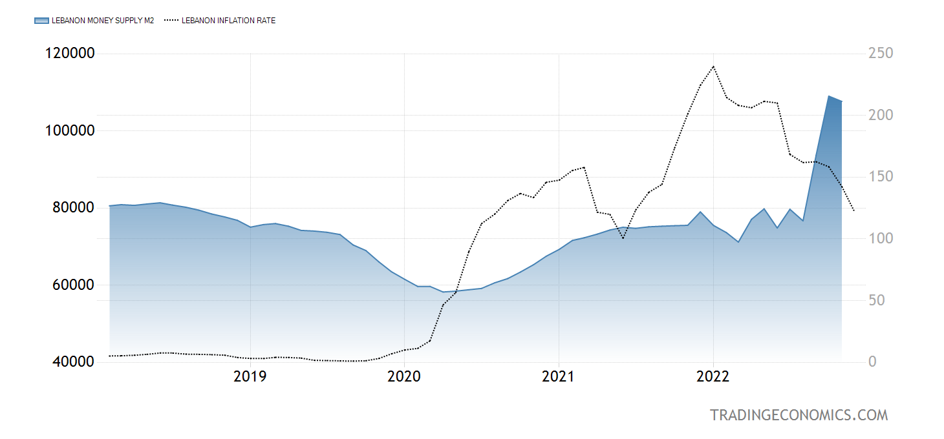Source: Trading Economics

The money supply and inflation rate for the previous five years are depicted in the graph above. The financial crisis and COVID reduced the nation's money supply. Additionally, the reduction in US dollar reserves was a factor. Inflation was constant until 2020 when COVID struck the country, and it began to increase. We can see an increase in the money supply and inflation by the end of 2020. Mid-through 2022, inflation started to decline, and the money supply began to rise. This may be the result of increased production output and the effectiveness of monetary policy in controlling inflation. Here, we are unable to establish a consistent correlation between the money supply and inflation.

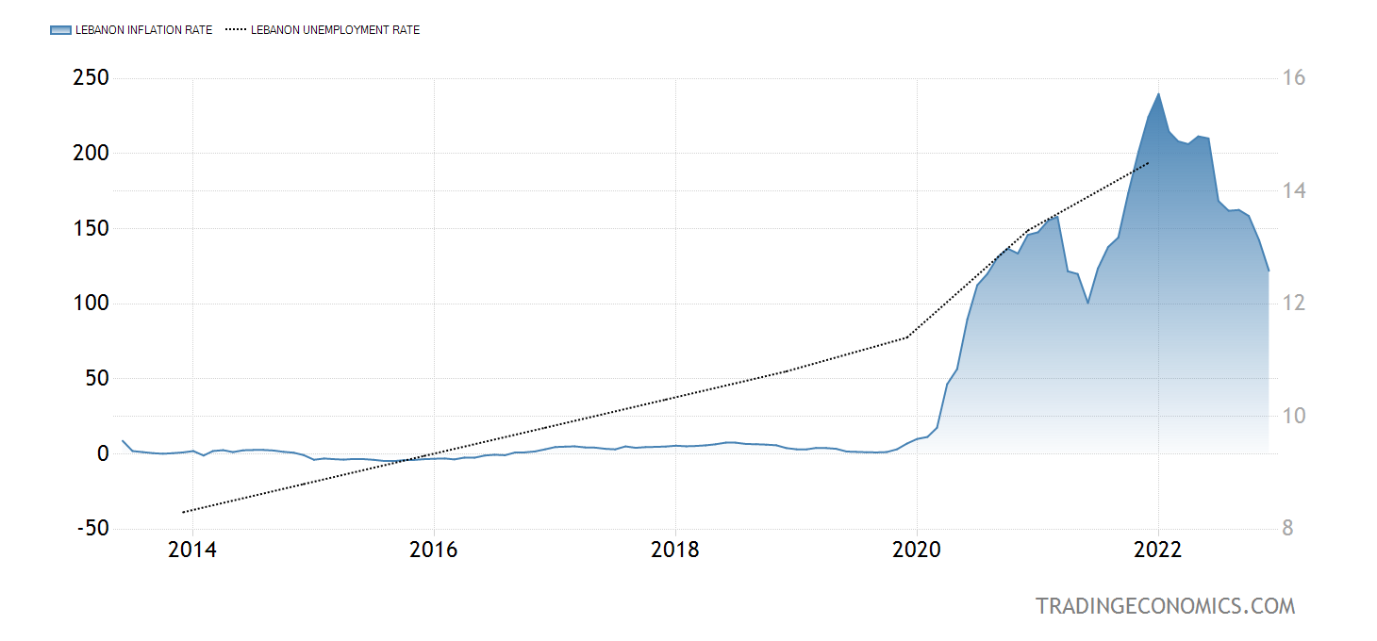

Source: Trading Economics

According to the graph above, unemployment remained steady from 2014 to 2020, although inflation rates increased gradually during the same period. In 2020, which was the COVID era, both inflation and unemployment climbed significantly. In 2020, there is just a very short period where there is a trade-off between inflation and unemployment.

CONCLUSION

It is evident from the previous section that the financial crisis, COVID, and the Beirut explosion had an adverse impact on the economy of Lebanon, which resulted in increasing inflation rates, unemployment, and poverty in the country. Decreasing US dollar reserves and its liquidity negatively affected the Lebanese pound. The long-term political unrest and ineffectiveness of Lebanon's policies are still hurting the country's economy.

QUESTION AND ANSWER

1. How does the country's declining US dollar liquidity and reserves impact the Lebanese economy?

The US dollar is one of the most significant currencies in Lebanon. With the help of its contributions, Lebanon is able to pay its debts and other essential everyday obligations. For a long time, US dollars were used as a means of exchange for exchanging the Lebanese pound. The main source of US cash was the service industry. Around 2011, as battles broke out in Syria, the flow of US dollars began to decline. US currency liquidity began to decline. The Lebanese pound declined as a result. Exports were cheap and imports were expensive as a result of currency devaluation. This increased inflation rates and worsened Lebanon's supply crisis.

1. What have been Lebanon's money supply and inflation patterns over the last five years?

The country's money supply was decreased as a result of COVID and the financial crisis. Furthermore, a contributing element was the decline in US dollar reserves. Before COVID hit the country in 2020, inflation was stable. After that, it started to rise. By the end of 2020, there is an increase in both the money supply and inflation. Midway through 2022, inflation began to fall, and the money supply increased. This could result from improved output production and the effectiveness of monetary policy in limiting inflation. Here, we are unable to establish a consistent correlation between the money supply and inflation

BIBLIOGRAPHY

(n.d.). Retrieved from https://www.worldbank.org/en/country/lebanon/overview

(n.d.). Retrieved from https://www.investopedia.com/terms/i/inflation.asp

(n.d.). Retrieved from https://tradingeconomics.com/

Elia, J. Y. (2020). LEBANESE BANKS: A FACTOR OF THE CURRENT LEBANESE FINANCIAL CRISIS (2019–2020).

Lebanon Economic Monitor. (2021). *Document of the World Bank*.